
Total: 126
Weighting 6%
Year 11 ATAR Geography
Task 10A - Fieldwork Booklet
Unit 2 – Global Networks and Interconnections
Depth Study Two – Tourism
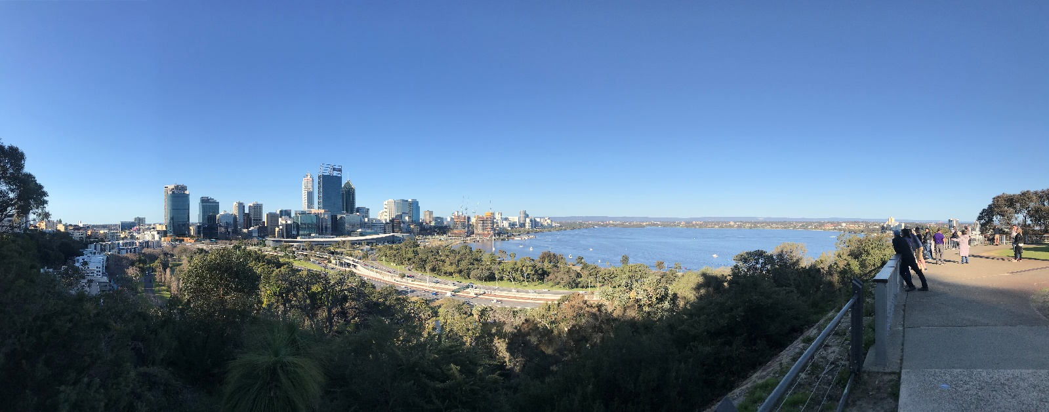
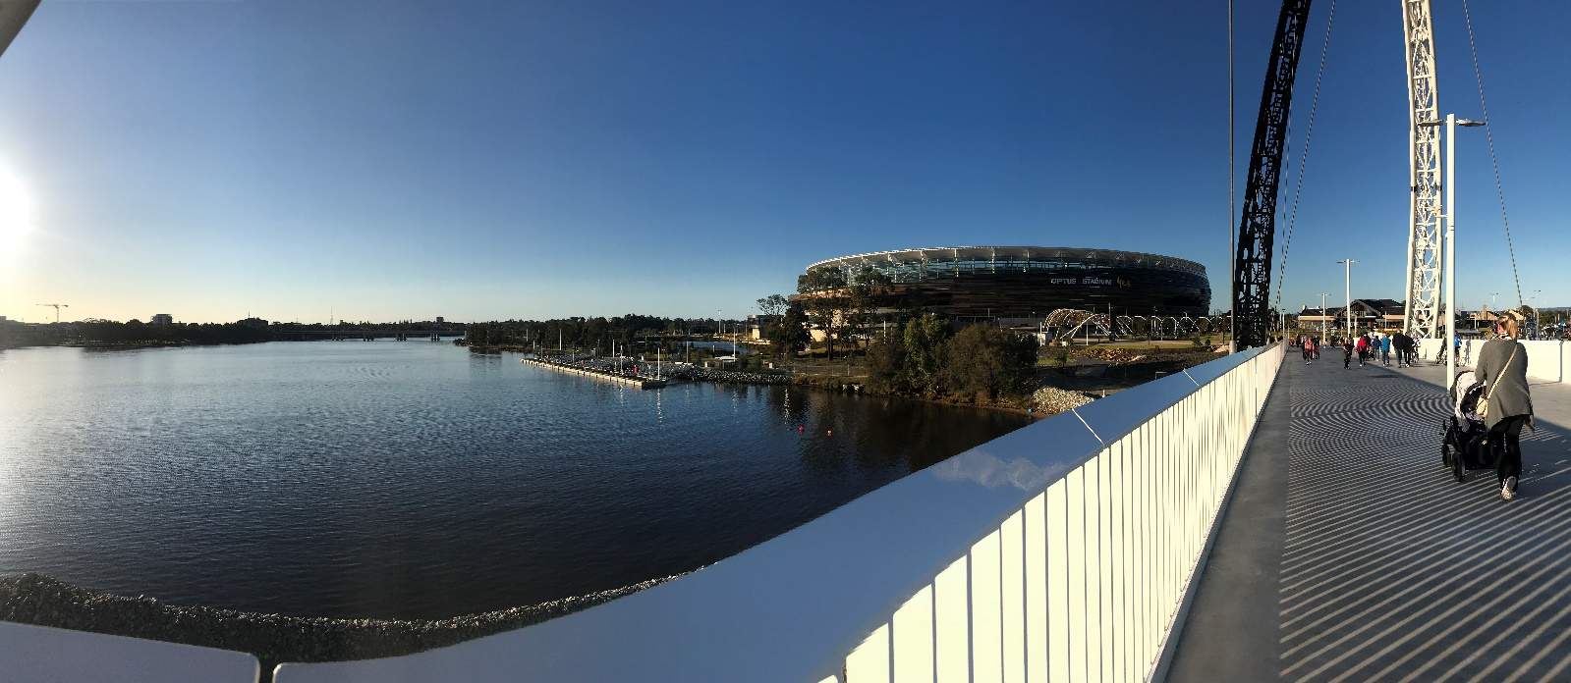

Name: _________________________________________
Date: __________________________________________
Background: Tourism in Perth
- Define Tourism. (2 marks)
______________________________________________________________________________________________________________________________________________________________________________

Scan the QR code. Read the source and complete the following questions.
- Using the source, describe reasons why Perth, Australia is a tourism destination. (3 marks)
______________________________________________________________
______________________________________________________________
______________________________________________________________
______________________________________________________________________________________________________________________________________________________________________________
- Click on “Things to Do in Perth” and list the top 5 attractions in Perth. (5 marks)

- ________________________________________________________________
- ________________________________________________________________
- ________________________________________________________________
- ________________________________________________________________
- ________________________________________________________________
Site One: Kings Park and Botanical Gardens
Use field observations and measurements complete the following activities.
Go to Kaarta-Gar-up look out.
Complete the following to collect data regarding the SITUATION of Kings Park.
- Research and state the location of the Point Zero Geographical Marker is for Perth City. (1 Mark)
________________________________________________________________________
- Using Google maps, measure and state the straight-line distance between Kaarta-Gar-up (Lookout) and the Point Zero Marker for Perth. (1 mark)

________________________________________________________________________

- State the direction of Kaarta Gar-up Lookout from the point Zero Marker for Perth. (1 mark)
________________________________________________________________________
- Using Google maps, determine the latitude and longitude Kings Park and Botanical Gardens. (1 mark)

___________________________________________________________________________

- Scan the QR code. Determine the approximate range in height above sea level and and topography for Kings Park by using the interactive topographic map. (2 marks)
_____________________________________________________________
_____________________________________________________________
- Scan the next QR code, study the satellite image of Kings Park and use observations to determine the type and density of vegetation. (2 marks)
_________________________________________________________________

_________________________________________________________________
_________________________________________________________________

- Using the information, you have collected, outline two Site and Situation features/characteristics of Kings Park and Botanic Gardens. (4 marks)

Site
- ____________________________________________________________________________________________________________________________________________________________________________________________________________________________________________________________________________________________________________________________________________________

- ____________________________________________________________________________________________________________________________________________________________________________________________________________________________________________________________________________________________________________________________________________________
Situation
- ____________________________________________________________________________________________________________________________________________________________________________________________________________________________________________________________________________________________________________________________________________________

- ____________________________________________________________________________________________________________________________________________________________________________________________________________________________________________________________________________________________________________________________________________________

- Draw a field sketch: looking out over the CBD and the Swan River, in an easterly direction, complete a quick sketch of the area in front of you. Remember to use pencil and include a title. (10 marks)

Locate and annotate the following features in your sketch:
- Swan River
- Central Business District
- Elizabeth Quay
- Darling Scarp
- South Perth Ferry Terminal
- Major Transport Links – Kwinana Freeway
- Perth Convention Centre
- South Perth Apartments
- Location of Perth Airport (Distance and Direction)

Hints:
- Only show main features
- Make sure your sketch is clear and easy to read/understand
- Ensure you annotate your sketch by adding brief notes (2 – 3 words for each note)
- You may like to use a key to add extra notes and differentiate between features
- You may like to take a photo to help with the completion of your sketch

Fieldwork Sketch
Title: _______________________________________________________________________________ Date: _____________________________________

Take a walk around the park, making observations and collecting primary data to answer the questions below.
- Make a 5 list of features of Kings Park and Botanic Garden that make it a tourism asset. (5 marks)

- _________________________________________________________________________________
- _________________________________________________________________________________
- _________________________________________________________________________________
- _________________________________________________________________________________
- _________________________________________________________________________________
- List 3 transport options used to access Kings Park and Botanic Garden. (3 marks)

- _________________________________________________________________________________
- _________________________________________________________________________________
- _________________________________________________________________________________
- Identify an example of an enterprise at Kings Park. Outline their role in the internationalisation of the production and consumption of tourism. (Hint: How do they contribute to tourism?) (3 marks)
Example: ____________________________________________________________________________
________________________________________________________________________________________________________________________________________________________________________________________________________________________________________________________________________________________________________________________________________________________________________________________________________________________________________________________________________________________________________________________
- Make a list of 5 facilities that are present at Kings Park that contribute to the accessibility as a tourism destination. (5 marks)
- _________________________________________________________________________________
- _________________________________________________________________________________
- _________________________________________________________________________________
- _________________________________________________________________________________
- _________________________________________________________________________________

- Look for signage. BGPA is a government department responsible for Kings Park. State what BGPA stands for. (1 mark)
______________________________________________________________


- Outline their role in the internationalisation of the production and consumption of tourism, include supporting evidence from the source. (Hint: How do they contribute to tourism?) (3 marks)
_____________________________________________________________
_____________________________________________________________
_____________________________________________________________
_____________________________________________________________
________________________________________________________________________________________________________________________________________________________________________________________________________________________________________________________________________________________________________________________________________________
________________________________________________________________________________________________________________________________________________________________________
- Using observations, complete the following. What if… there is a cable car built that connected Kings Park to Elizabeth Quay? Outline the potential impacts this would have on the following: (6 marks)

- Economy
________________________________________________________________________________________________________________________________________________________________________________________________________________________________________________________________________________________________________________________________________________________________________________________________________________________________________________________________________________________________________________________________________________________________________________________________________________________________________________________________________________________________
- Visitors to Kings Park
____________________________________________________________________________________________________________________________________________________________________________________________________________________________________________________________________________________________________________________________________________________________________________________________________________________________________________________________________________________________________________________________________________________________________________________________________________________________________________________________________________________________________________________________________________________________________________________
- The Environment
________________________________________________________________________________________________________________________________________________________________________________________________________________________________________________________________________________________________________________________________________________________________________________________________________________________________________________________________________________________________________________________________________________________________________________________________________________________________________________________________________________________________

Scan the QR codes. Use the information in the sources and your observations to complete the question.



Extra Space for notes and observations:

Site Two: Optus Stadium

Use field observations and measurements complete the following activities. Note* you may complete this before or after the tour.
Go to Gate D.

Complete the following to collect data regarding the SITUATION of Optus Stadium.
- Using Google maps, measure and state the straight-line distance between Optus Stadium and the Point Zero Marker for Perth. (1 mark)
________________________________________________________________________

- State the direction of Optus Stadium from the point Zero Marker for Perth. (1 mark)
________________________________________________________________________
- Using Google maps, determine the latitude and longitude of Optus Stadium. (1 mark)

___________________________________________________________________________

- Scan the QR code. Determine the approximate range in height above sea level and topography for Optus Stadium by using the interactive topographic map. (2 marks)
_____________________________________________________________
_____________________________________________________________

- Observe the area around you and make observations about the vegetation. (2 marks)

_____________________________________________________________
_____________________________________________________________
- Using the information, you have collected, outline two Site and Situation features/characteristics of Optus Stadium. (4 marks)

Site
- ____________________________________________________________________________________________________________________________________________________________________________________________________________________________________________________________________________________________________________________________________________________

- ____________________________________________________________________________________________________________________________________________________________________________________________________________________________________________________________________________________________________________________________________________________
Situation
- ____________________________________________________________________________________________________________________________________________________________________________________________________________________________________________________________________________________________________________________________________________________

- ____________________________________________________________________________________________________________________________________________________________________________________________________________________________________________________________________________________________________________________________________________________
Take a walk around the Optus Stadium Precinct, making observations and collecting primary data to answer the questions below.
- Make a 5 list of features of Optus Stadium that make it a tourism asset. (5 marks)

- _________________________________________________________________________________
- _________________________________________________________________________________
- _________________________________________________________________________________
- _________________________________________________________________________________
- _________________________________________________________________________________
- List 4 transport options used to access Optus Stadium. (4 marks)

- _________________________________________________________________________________
- _________________________________________________________________________________
- _________________________________________________________________________________
- _________________________________________________________________________________
- State an example of an enterprise at Optus Stadium. Outline their role in the internationalisation of the production and consumption of tourism. (Hint: How do they contribute to tourism?) (3 marks)
________________________________________________________________________________________________________________________________________________________________________________________________________________________________________________________________________________________________________________________________________________________________________________________________________________________________________________________________________________________________________________________________________________________________________________________________________________________________________________________________________________________________
- Make a list of 5 facilities that are present at Optus Stadium that contribute to the accessibility as a tourism destination. (5 marks)
- _________________________________________________________________________________
- _________________________________________________________________________________
- _________________________________________________________________________________
- _________________________________________________________________________________

- _________________________________________________________________________________
Scan the QR code. Use the source to complete the questions below.
State the name of the Government Department mentioned in the source. (1 mark)
______________________________________________________
- Outline their role in the internationalisation of the production and consumption of tourism, include supporting evidence from the source. (Hint: How do they contribute to tourism?) (3 marks)
____________________________________________________________________________________________________________________________________________________________________________________________________________________________________________________________________________________________________________________________________________________________________________________________________________________________________________________________________________________________________________________________________________________________________________________________________________
Use your observations to complete the questions below.
- Optus Stadium’s role in the production and consumption of Tourism. Describe how each of the following initiatives will help to increase the production and consumption of tourism in Western Australia. (6 marks)

- Major Events
____________________________________________________________________________________________________________________________________________________________________________________________________________________________________________________________________________________________________________________________________________________________________________________________________________________________________________________________________________________________________________________________________________________________________________________________________________

- Matagarup Bridge
____________________________________________________________________________________________________________________________________________________________________________________________________________________________________________________________________________________________________________________________________________________________________________________________________________________________________________________________________________________________________________________________________________________________________________________________________________

- Outdoor Amphitheatre
____________________________________________________________________________________________________________________________________________________________________________________________________________________________________________________________________________________________________________________________________________________________________________________________________________________________________________________________________________________________________________________________________________________________________________________________________________
Scan the QR codes below. Read the articles for extra information.




Major Events

Matagarup Bridge




Outdoor Amphitheatre


- Draw a field sketch: Arriving at Gate D looking out over towards the CBD in a westerly direction, complete a quick sketch of the area in front of you. Remember to use pencil and include a title.
(10 marks)

Label the following:
- Swan River
- Central Business District
- Optus Stadium
- BHP Boardwalk
- Matagarup Bridge
- Hotels in South Perth
- Outdoor Amphitheatre

Hints:
- Only show main features
- Make sure your sketch is clear and easy to read/understand
- Ensure you annotate your sketch by adding brief notes (2 – 3 words for each note)
- You may like to use a key to add extra notes and differentiate between features
- You may like to take a photo to help with the completion of your sketch
Fieldwork Sketch
Title: _______________________________________________________________________________ Date: _____________________________________
- Make notes and observations during your tour of Optus Stadium; particularly in relation to tourism in Perth and the role of Optus Stadium. (20 marks)

Name of Tour Guide: ____________________________________________________________________________
Facts about the Stadium as a Venue for Major Events and how this contributes to Tourism.
________________________________________________________________________________________________________________________________________________________________________________________________________________________________________________________________________________________________________________________________________________________________________________________________________________________________________________________________________________________________________________________________________________________________________________________________________________________________________________________________________________________________________________________________________________________________________________________________________________________________________________________________________________________________________________________________________________________________________________________________________________________________________________________________________________________________________________________________________________________________________________________________________________________________________________________________________________________________________________________________________________________________________________________________________________________________________________________________________________________________________________________________________________________________________________________________________________________________________________________________________________________________________________________________________________________________________________________________________________________________________________________________________________________________________________________________________________________________________________________________________________________________________________________________________________________________________________________________________________________________________________________________________________________________________________________________________________________________________________________________________________________________________________________________________________________________________________________________________________________________________________________________________________________________________________________________________________________________________________________________________________________________________________________________________________________________________________________________________________________________________________________________________________________________________________________________________________________________________________________________________________________________________________________________________________________________________________________________________________________________
Facts about the Stadium and how it caters for visitors and tourists.
____________________________________________________________________________________________________________________________________________________________________________________________________________________________________________________________________________________________________________________________________________________________________________________________________________________________________________________________________________________________________________________________________________________________________________________________________________________________________________________________________________________________________________________________________________________________________________________________________________________________________________________________________________________________________________________________________________________________________________________________________________________________________________________________________________________________________________________________________________________________________________________________________________________________________________________________________________________________________________________________________________________________________________________________________________________________________________________________________________________________________________________________________________________________________________________________________________________________________________________________________________________________________________________________________________________________________________________________________________________________________________________________________________________________________________________________________________________________________________________________________________________________________________________________________________________________________________________________________________________________________________________________________________________________________________________________________________________________________________________________________________________________________________________________________________________________________________________________________________________________________________________________________________________________________________________________________________________________________________________________________________________________________________________________________________________________________________________________________________________________________________________________________________________________________________________________________________________________________________________________________________________________________________________________________________________________________________________________________________________________________________________________________________________________________________________________________________________________________________________________________________________________________________________________________________________________________________________________________________________________________________________________________________________________

